**TRACKING AND DIAMETER ESTIMATION OF RETINAL VESSELS USING GAUSSIAN PROCESS AND RADON TRANSFORM**

***A report on major project work***

Submitted in the partial fulfillment of the requirements for

the award of the degree of

**BACHELOR OF TECHNOLOGY**

*in*

**ELECTRONICS AND COMMUNICATION ENGINEERING**

*by*

**P. Hrushika B17EC155**

**B. Venkata Saiteja B17EC150**

**B. Hemanth B17EC148**

**K. Srividya B18EC209L**

Under the guidance of

**P. Yugender**

Designation, Department of ECE.



**DEPARTMENT OF ELECTRONICS & COMMUNICATION ENGINEERING KAKATIYA INSTITUTE OF TECHNOLOGY & SCIENCE, WARANGAL**

*(An Autonomous Institute under Kakatiya University, Warangal)*

**WARANGAL – 506015**

**2020-2021**

**KAKATIYA INSTITUTE OF TECHNOLOGY AND SCIENCE, WARANGAL**

**DEPARTMENT OF ELECTRONICS & COMMUNICATION ENGINEERING**



**CERTIFICATE**

This is to certify that the project work entitled “**TRACKING AND DIAMETER ESTIMATION OF RETINAL VESSELS USING GAUSSIAN PROCESS AND RADON TRANSFORM**” is the bonafide project work carried out by **P. Hrushika, B. Venkata Saiteja, B. Hemanth** and **K. Srividya** bearing Roll.Nos**. B17EC155, B17EC150, B17EC148** and **B18EC209L** respectively, in partial fulfillment of the requirements for the award of degree of the Bachelor of Technology from Kakatiya Institute of Technology and Science, Warangal during the academic year 2020-2021.

**Project Guide Head of the Department**

**P. Ygender Dr. B. Ramadevi**

Designation of the faculty, Professor & Head,

Dept. of ECE, Dept. of ECE,

KITS, Warangal. KITS, Warangal.

**DECLARATION**

We declare that the work presented in this project report is original and has been carried out in the Department of Electronics & Communication Engineering, Kakatiya Institute of Technology and Science, Warangal, Telangana, and to best of our knowledge it has been not submitted elsewhere for any degree.

**P. HRUSHIKA**

Roll No. B17EC155

**B. VENKATA SAITEJA**

Roll No. B17EC150

**B. HEMANTH**

Roll No. B17EC148

**SRIVIDYA**

Roll No. B18EC209L

**ACKNOWLEDGEMENT**

We express our deepest sense of gratitude and indebtedness to our project guide **P. Yugender,** Designation of the faculty, Dept. of ECE, KITS, Warangal for having been a source of consistent inspiration, precious guidance and generous assistance during project work. We deem it as a privilege to have worked under his able guidance. Without his close monitoring and valuable suggestions this work wouldn’t have taken this shape. We feel that this help is not substitutable and unforgettable.

We are thankful to B. Tech Project work Convener, **Smt. A. Vijaya**, Associate Professor, Dept. of ECE, KITSW, Project work Coordinators **B. Narsimha**, Assistant Professor, **P. Chiranjeevi**, Assistant Professor and **R. Srikanth**, Assistant Professor, Dept. of ECE, KITSW for timely conduction of seminars.

We are profoundly thankful to **Dr. B. Ramadevi,** Professor & Head, Dept. of ECE for her constant support and encouragement.

We express our sincere thanks to [**Dr. K.**](http://www.kitsw.ac.in/principle_message.html) **Ashoka Reddy**, Principal, KITS, Warangal, for his kind gesture and support.

We are indebted to the Management of Kakatiya Institute of Technology and Science, Warangal, for providing the necessary infrastructure and good academic environment in an endeavour to complete the project and special thanks for providing Department Library of ECE and Digital Library to access IEEE papers.

We would like to acknowledge the faculty and non-teaching staff of Electronics and Communication Engineering Department. We are thankful to **Name of the Lab Assistant**, Lab Assistant, **Name of the laboratory** for his help and cooperation during our project work.

**P. Hrushika**

**B. Venkata Saiteja**

**B. Hemanth**

**K. Srividhya**

**ABSTRACT**

Extraction of blood vessels in retinal images is an ongoing challenge in medical image analysis and an important step for computer-aided diagnosis of ophthalmic pathologies. Accurate measurement of vessel diameters on retinal images plays an important role in diagnosing cardiovascular diseases and early signs of certain systemic diseases, such as diabetic retinopathy and hypertension.

Biomedical image segmentation provides the foundation for quantitative description on retinal vessels. Automated and accurate segmentation of the retinal blood vessel is one of the challenging tasks in the computer-aided analysis of fundus images today. Retinal vessel diameter was measured based on blood vessel wall estimating on the retinal fundus image.

We determine the curvature and the diameter of blood vessels by applying Gaussian processes (GP). Local Radon transform, which is robust against noise, is subsequently used to compute the GP. By getting the kernelized covariance matrix from training data, vessel direction and its diameter are estimated. In order to determine bifurcations, multiple GP are deployed for estimation of the directions. The increased difference between estimated directions from each of these GP is used to detect bifurcations. The combination of Radon features and GP results in a significantly improved performance in dealing with thin and noisy vessels. In this project we are going to use high-resolution images from DRIVE, STARE, and CHASEDB1 databases.

**Software Requirement:**

MATLAB 2020a

**TABLE OF CONTENTS**

|  |  |  |  |  |
| --- | --- | --- | --- | --- |
| **Chapter** |  | **Content** | **Page.No.** | |
|  | Title Page | | i | |
|  | Certificate | | ii | |
|  | Declaration | | iii | |
|  | Acknowledgement | | iv | |
|  | Abstract | | V | |
|  | Table of Contents | | Vi | |
|  | List of figures | | Vii | |
|  | List of tables | | Viii | |
| Chapter 1 | Introduction | | 1 | |
| Chapter 2 | Literature Review | | 3 | |
| Chapter 3 | Objectives of the Project | | 4 | |
| Chapter 4 | Existing Algorithms | | 5 | |
| Chapter 5 | Gaussian process | | 6 | |
| Chapter 6 | Radon transform | | 8 | |
| Chapter 7 | Block diagram | | 9 | |
| Chapter 8 | Proposed method | | 11 | |
|  | 8.1 Vessel centerline tracking | | 11 | |
|  | 8.1.1 Estimation of kernel hyper parameter | | | 13 |
|  | 8.2 Bifurcation detection | | | 15 |
|  | 8.3 Diameter estimation | | | 16 |
| Chapter 9 | Software description | | 19 | |
| Chapter 10 | Advantages and Limitations | | 22 | |
| Chapter 11 | Applications | | 23 | |
| Chapter 12 | Dataset | | 23 | |
| Chapter 13 | Algorithm | | 25 | |
| Chapter 14 | Results | | 26 | |
| Chapter 15 | Conclusion | | 32 | |
|  | References | | 34 | |
|  |  | |  | |

**LIST OF FIGURES**

|  |  |  |  |
| --- | --- | --- | --- |
| **Figure No.** | **Figure Name** | **Page. No.** | |
| Figure 6.a | radon transform feature extraction | | **8** | |
| Figure7.a | Block diagram | | 9 | |
| Figure8.1.a | Vessel centerline tracking | | 11 | |
| Figure8.1.b | Radon transform-based feature extraction algorithm | | 12 | |
| Figure8.1.c | Schematic of blood centerline tracking | | 12 | |
| Figure8.2.a | Approaching the bifurcations , the difference between t 1 and t 2 increases | | 15 | |
| Figure8.2.b | A real extracted feature vector | | 15 | |
| Figure8.2.c | A synthetic feature vector with two target values (-40, 20) | | 15 | |
| Figure8.3.a | Compute radon tf, setting $α= θ_{N+1}$ | | 17 | |
| Figure8.3.b | Training data generated for diameter estimation | | 17 | |
| Figure8.3.c | **flowchart** | | 18 | |
| Figure 9.a | MATLAB | | 20 | |
| Figure 12.a | Images from DRIVE dataset | | 24 | |
| Figure 12.b | Images from STARE dataset | | 24 | |
| Figure 12.c | Images from CHASEDB1 dataset | | 24 | |
| Figure 14.a | results for DRIVE image1 | | 26 | |
| Figure 14.b | results for DRIVE image2 | | 26 | |
| Figure 14.c | results for STARE image1 | | 27 | |
| Figure 14.d | results for STARE image2 | | 28 | |
| Figure 14.e | results for CHASEDB1 image1 | | 28 | |
| Figure 14.f | results for CHASEDB1 image2 | | 29 | |

**LIST OF TABLES**

|  |  |  |  |  |
| --- | --- | --- | --- | --- |
| **S.No.** | | **Table Name** | | **Page. No.** |
|  | |  | |  |
| Table 9.a | | Matlab functions and its description | | 21 |
| Table 14.a | | Comparison of proposed method with existing methods | | 31 |
|  |  | |  | | |
|  |  | |  | | |

1. **INTRODUCTION**

Retina which is located in the back of the eye contains useful information in the diagnosis of certain retinal diseases. Analysis of vascular structures in the retinal images is very important for diagnosis of different pathologies related to diabetes, cardiovascular disorders, and hypertension. In each case if the patient is not correctly diagnosed or treated in a timely manner, the diseases will spread and cause adult blindness. By locating a blood vessel’s width and abnormal branching, one can deduce the existence of the diseases mentioned above. In order to achieve this, at first blood vessels need to be extracted from its background in the fundus image. For example, diabetic retinopathy can be detected early by examining morphological variations in vasculatures which helps in prevention of vision loss and blindness.

To measure these difficulty, precise retinal vessel detection and diameter estimation need to be known. Generally, semiautomatic or automatic vessel segmentation tools are lodged over manual description, because the latter is hard and dependent on user. However, due to imaging defect and noise, accurate delineation foist a special challenge on non-manual methods, particularly when thin vessels are of perturb.

A wide vary of vessel extraction ways from medical pictures has been projected within the literature. However, every technique solely excels in a very few explicit quality aspects like procedure load, hardiness to variation of region of interest, and imaging modality. The performance of vessel segmentation ways will typically be improved by a preprocessing step. The aim of this stage is to accentuate valuable info and eliminate noise that might otherwise adversely have an effect on the ultimate outcome. Completely different ways are projected for this purpose. Even supposing a preprocessing step might improve segmentation, it will cause loss of vital options, notably at edges and slender vessels. Therefore, despite some relative successes, vessel extraction still remains a vigorous analysis space.

The current spotlight papers in this area are as follows:

Azzopardi et al. proposed a filter based on a mutation of shifted filter responses that is tactful to vessels. Carrying on with the before work, Strisciuglio et al. choosed the filters in an automatic process that selects for the best-performing one. Orlando et al. used a conditional random field model and fully connected pairwise potentials to draw out retinal vasculature. Deep neural networks have now entered the retinal image segmentation field by Liskowski and Krawiec. After applying a preprocessing step, they use many deep learning architectures to segment vessels. Second-order provincially adaptive derivatives have been used in various papers for bring out vessel structures; Zhang et al. proposed a easier version of this method by eliminating a computation of full Laplacian in vessel enhancements (geometric diffusions), which is much easy to understand and replicate.

In this paper we introduce a new method to track blood vessel centerlines, bifurcation detection and diameter estimation. Blood vessel centerline tracking is done by using GP regression and Radon transform. Detection of bifurcation and tracking the diameter is done by using multiple GP’s.

At first we tend to assume one fragment of a vessel having no bifurcations and therefore the curvature and therefore the diameter usually vary swimmingly in such how that the new direction and diameter of the vessel may be statistically foretold from past values. We tend to exploit these properties as previous data and hypothesize that the curvature and therefore the diameter of blood vessels area unit mathematician processes (GPs). To achieve any noise lustiness, we tend to train the GPs by computing the native options that is finished mistreatment argon on rework. In determination of bifurcations, multiple GPs area unit deployed for estimation of the directions. The distinction between calculable directions from every of those GPs is employed to find bifurcation points. Combining mathematician Progressions with argon on options ends up in a considerably improved performance in addressing skinny and clanging vessels.

We evaluated the proposed method on the following three publicly available data-sets: DRIVE, STARE, CHASEDB1, HRF. A brief review of GP regression and radon transform is presented in chapter 4 and 5 respectively. The block diagram in chapter 6 and this is followed by the proposed method in chapter 7.

## LITERATURE REVIEW

[1].Radhika Y, Santhosh Kumar NC, “optimized maximum principal curvature-based segmentation of blood vessels from retinal images”, Biomedical Research 2019, Vol 30, Issue 2, pp. 308-318.

[2].Verma K, Deep P, Ramakrishnan AG. “Detection and classification of diabetic retinopathy using retinal images flight”. Annual IEEE India Conference (INDICON) 2011, pp 1-6.

[3].Ikibas C. ,Kose C, “A personal identification system using retinal vasculature in retinal fundus images”. Exp Sys Appl 2011, Vol. 38, pp. 13670-13681.

[4].G. Azzopardi et al., “Trainable COSFIRE filters for vessel delineation with application to retinal images,” Med. Image Anal. 19(1), 46–57 (2015).

[5].N. Strisciuglio et al., “Supervised vessel delineation in retinal fundus images with the automatic selection of B-COSFIRE filters,” Mach. Vision Appl. 27(8), 1137–1149 (2016).

[6].J. I. Orlando, E. Prokofyeva, and M. B. Blaschko, “A discriminatively trained fully connected conditional random field model for blood vessel segmentation in fundus images,” IEEE Trans. Biomed. Eng. 64(1), 16– 27 (2017).

[7]. J. Zhang et al., “Robust retinal vessel segmentation via locally adaptive derivative frames in orientation scores,” IEEE Trans. Med. Imaging 35(12), 2631–2644 (2016).

## OBJECTIVE OF THE PROJECT

To track blood vessel using GP regression and Radon transform. Next detection of bifurcations and tracking the diameters using multiple GPs. To estimate the retinal vessel direction and diameter performance of proposed method on vessels without bifurcation i.e. linear vessel and also with bifurcation. Images affected by various levels of Gaussian noise used to evaluate robustness of proposed method.

## EXISTING ALGORITHM

Most of the existing methods are based on unsupervised, supervised and matched filter techniques. In matched filtering techniques the methods are based on matched filtering techniques, the profile of vessels can be modeled with a two-dimensional Gaussian kernel, also in combination with an orientation score. In the unsupervised approaches, mathematical morphology techniques are used in combination with a priori knowledge about the vessels structure or with curvature analysis. Vessel tracking-based methods start from an automatically or manually chosen set of points and segment the vessels by following their centerline. The Supervised methods are based on machine learning techniques and typically require high-dimensional pixel-wise feature vectors to train a classifier that discriminates vessel from non-vessel pixels.

G. Azzopardi et al., proposed method is based on the bar-selective COSFIRE filter, or B-COSFIRE, a trainable filter approach method which is used to detect bar-shaped structures like blood vessels. The selectivity of the filter is determined from the user-specified prototype pattern like a straight vessel, bifurcation point. The approach is an unsupervised way.

J. Zhag et al., proposed a novel retinal vessel segmentation approach based on a simpler version of a 2nd-order locally adaptive derivative which avoids computation of geometric diffusions. This paper follows LAD-OS approach which gives good performance even with a small number of orientation sampling. Here after preprocessing of the image OS transformation is applied then the binary map is derived by applying a proper thresholding between the LID filter set up which is applied on the Left-invariant frame and the LAD filter set up applied on the OS hessian matrix.

N. Strisciuglio et al., used two *B*-COSFIRE filters by means of information theory and machine learning, one specific for the detection of vessels and the other for the detection of vessel-endings, were combined together by simply summing up their responses. Here the configuration parameters of each filter were chosen in order to perform best on the most common thickness of all vessels. It uses different feature selection methods, including Generalized Matrix Learning Vector Quantization (GMLVQ), class entropy and a genetic algorithm.

J. I. Orlando., here the blood vessel segmentation task is posed as an energy minimization problem in the CRF(conditional random field). Here images are mapped to the graphs, where each pixel represents a node, and every node is connected with an edge to their neighbors according to a certain connectivity rule. Here 1 is associated with the blood vessels and and -1 to the other class. Gibbs energy function is derived from the likelihood distribution, minimizing this energy MAP (maximum a posteriori), then a binary segmentation of the vasculature is obtained. By the graph connectivity, similar distribution is obtained. Unary potentials are common to both the local neighborhood based and the fully connected CRF (FC-CRF).

## GAUSSIAN PROCESS

A GP is a supervised learning method. GP layout a principal, practical, and probabilistic appeal to learn these relations utilizing kernels. In GP, having observed N input vectors $x_{1}$**, … , $x_{N}$** , and their corresponding output variables $t_{1}$**, …. , $t_{N}$**, we wish to make a prediction for new input $x_{N+1}$ that we have not seen in the training dataset.

For linear regression of values of t, we define the model predicted values using **y(x)= $W^{T}$ ϕ(x),** a linear combination of M fixed basis functions given by the elements of the vector **ϕ(x)**, where w is an M-dimensional weight vector. The relationship between the observed and predicted variables is modeled as $t_{n}$**= $y_{n}$ + $ε_{n}$,** where yn $y_{n}=y(x_{n})$ and $ε_{n}$**,** is a Gaussian noise variable. If the values of $y_{1}$**, … , $y_{N}$** , become jointly Gaussian distributed, the function y(x) is said to be a GP.

Thus, we are interested in the joint Gaussian distribution of the function values $y(x_{1})$**, … , $y(x_{N})$** , which is denoted by the vector y given by

**Y = Φw**

where Φ is the design matrix. In practice, since we do not have any prior knowledge about the mean of y(x), it is set to zero. This assumption is equal to choosing the mean of the prior over the weight values, i.e., p(w|α), to be zero in the basis function viewpoint.

The joint distribution of the target values $t_{N}= {(t_{1}, …, t_{N})}^{T}$**,** conditioned on the values of $y= {(y_{1}, …, y_{N})}^{T}$

is given by an isotropic Gaussian

$$P\left(t_{N}|y_{N}\right)= N(t_{N}|y_{N},β^{-1}I_{N})$$

where $I_{N}$ denotes the N × N identity matrix, and β is the precision of the random noise.

According to the definition of GP, the marginal distribution p( $y_{N})$ is a Gaussian distribution of zero mean and its covariance is defined by a Gram matrix K

$$P\left(y\right)= N(y_{N}|0,K)$$

The kernel function, which determines K, is typically defined to show the property that for close enough. The marginal distribution p($t_{N}$), conditioned on the input values $x_{1}$**, … , $x_{N}$** , which is given by

$$P\left(t_{N}\right)= N(t_{N}|0,C_{N})$$

where the elements of covariance matrix CN are

$$C\left(x_{n},x_{m}\right)=k\left(x_{n},x_{m}\right)+β^{-1}δ_{nm}$$

The joint distribution over $t_{N+1}= {(t_{1}, …, t_{N+1})}^{T}$ is given as

$$P\left(t_{N+1}\right)= N(t_{N+1}|0,C_{N+1}$$

Gaussian distribution with mean and covariance is as

$$m\left(x_{N+1}\right)=k^{T}C_{N}^{-1}t_{N}$$

$$σ^{2}\left(x_{N+1}\right)={c-k}^{T}C_{N}^{-1}$$

where $C_{N}$ is a covariance matrix with elements.

These equations are the key results that specify a GP regression. The prediction values in GP are firmly managed by covariance function.

Typical techniques to train the hyperparameters are based on the evaluation of the likelihood function **p(|θ),** where the hyperparameters of the GP are denoted by θ. By estimating θ and maximizing the log likelihood function, the hyperparameters’ value can be obtained.

1. **RADON TRANSFORM**

The Radon transform is the [integral transform](https://en.m.wikipedia.org/wiki/Integral_transform), whose value at a particular line is equal to the [line integral](https://en.m.wikipedia.org/wiki/Line_integral) of the function over that line.

The Radon transform, ${\{\backslash displaystyle Rf\}{}_{}R_{f}}_{}$  , is a function specified on the space of straight lines {\displaystyle L\in \mathbb {R} ^{2}}L  by the [line integral](https://en.m.wikipedia.org/wiki/Line_integral#Definition) through each such line as:

{\displaystyle Rf(L)=\int _{L}f(\mathbf {x} )\vert d\mathbf {x} \vert .}

Concretely, the parameterization of any straight line *{\displaystyle L}* ‘L’ with respect to arc length ‘z’ {\displaystyle z} X can always be written:

(x(z),y(z))= (() , ())

where {\displaystyle s} is the distance of  {\displaystyle L}’L’ from the origin and {\displaystyle \alpha } is the angle the normal vector to *{\displaystyle L}*’L’ makes with the {\displaystyle X}X-axis.

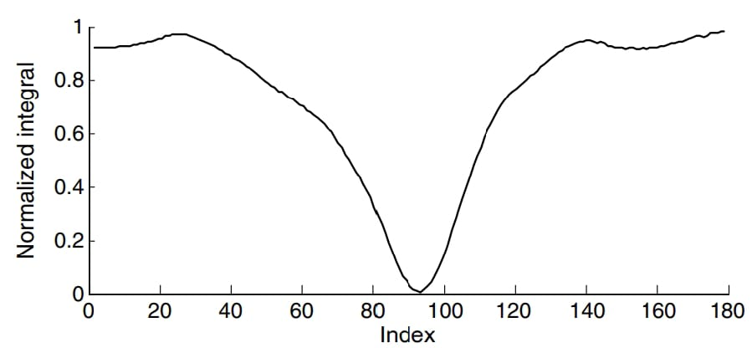

**Figure 6.a: radon transform feature extraction**

To track the centerlines of the vessels, at first feature extraction is to be done. These features are extracted by radon transform and this should be given as input to the Gaussian Progression.

The Radon transform in two dimensions (2-D) is given by integrating along lines having different distance (ρ) and angle (θ) values. In a 2-D Euclidean space, the Radon transform of a function g(x, y) is defined as

$$R\left(ρ,θ\right)= \int_{-∞}^{+∞}{\int_{-∞}^{+∞}{g\left(x,y\right)δ\left(ρ-x cosθ-y sinθ\right)dxdy}}$$

where δ(r) is the Dirac delta function whose value is infinite at zero and zero elsewhere.

## BLOCK DIAGRAM

**Figure 7.a: Block diagram**

**Retinal fundas images**

**Blood vessel** **detection**

**Vessel centerline** **tracking**

**Bifurcation detection**

**Diameter estimation**

**DRIVE**

**STARE**

**scanning**

**tracking**

**Radon** **transform**

**I/P**

**O/P**

At first a retinal fundus image from publicly available Drive or Stare dataset is given as the input. Fundus is nothing but a rear of an eye. Drive consists of 20 colour retinal images, each have 565*584 pixels with 8 bits per colour channel. Stare consists of 402 colour retinal images, each have 700*605 pixels with 8 bits per colour channel.

Next we detect the blood vessel, this strategy is divided into two major categories scanning and tracking. Scanning is a pixel based approach. Here number of features is computed for every pixel and based on these features each pixel is individually classified as a vessel or non-vessel sample. In tracking, we track a single vessel at a time rather than detecting entire vascular network. This approach provides accurate vessel specific width and other vascular network that is often unavailable using other methods.

Further we track the vessel centreline by using radon transform feature extraction. Before radon transform, weights are defined to each pixel. By advancing along the centreline two sets of training data are created for tracking both the directional variation and diameter of the lumen.

Simultaneously, to detect the bifurcations, different set of radon transform based features are used. In above step we use only single GP by which a branch with a larger deviation angle can be diminished. So, here we use multiple GP’s to enable tracking through both branches. Two independent GP’s are implemented to track the smaller and larger deviation angles. If the difference between them is higher than the threshold value then that particular point is indicated as bifurcation point. If it is less than it is chosen for moving along the vessel.

For the next step to estimate the diameter we use different set of radon featurs which are more appropriate for thickness detection

## PROPOSED METHOD

In the proposed method we delineate our blood vessel centerline tracking method with help of GP regression and Radon transform. Next, we furthermore extend the method to detect the bifurcations and track the diameters by numerous GPs.

The proposed method is carved up into three main steps, tracking the centerline in a simple vessel, detecting bifurcations and estimating the diameters.

**8.1 Vessel Centerline Tracking:**

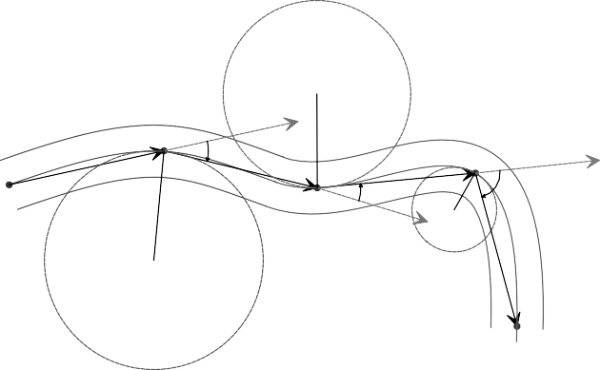

*O*1

*R* 2

*t*1

*O*3

*O*0

*θ* 0

*θ* 1

*θ* 2

*t*2

*t3*

*R* 1

*O*2

*R* 3

*θ* 3

**Figure 8.1.a : Vessel centerline tracking, here the assumption is curvature**

**of the vessel is directly proportional to the directional variation which**

**is a zero mean GP.**

In order to track blood vessel centerlines, we assume that in a single vessel fragment with no bifurcations. The curvature differ readily and has a Gaussian distribution. Therefore, we postulate that the curvature of blood vessels, by differentiating their positive and negative values, is a GP with a zero mean given by

$$P\left(t_{N}\right)= N(t_{N}|0,C_{N}$$

where $t_{N}= {(t_{1}, …, t_{N})}^{T}$ indicates the curvature along the vessel.

Curvature has a direct relationship with the directional variation, so the directional variation along a vessel is a zero mean GP. As the curvature rises, the respective directional variation also increases. An trump card of using directional variation, however, is that the positive and negative curvature values can be effortlessly known. We contemplate clockwise and anticlockwise directions as having positive and negative signs, respectively.

At first we need to track the centerlines is feature extraction. These features are extracted by Radon transform and used as an input ($x_{N}$) to the GP. The Radon transform in two dimensions (2-D) is given by integrating along lines having different distance (ρ) and angle (θ) values from the origin. In a 2-D Euclidean space, the Radon transform of a function g(x, y) is defined as

$$R\left(ρ,θ\right)= \int_{-∞}^{+∞}{\int_{-∞}^{+∞}{g\left(x,y\right)δ\left(ρ-x cosθ-y sinθ\right)dxdy}}$$

where δ(r) is the Dirac(delta) function whose value is infinite at zero and zero elsewhere.

Radon transform cancels the noise by the integration process.

To extract these features we need to do the following settings:

$$ρ=0 ; θ= θ_{N}- 89 deg,….,θ_{N}-1 deg,θ_{N},θ_{N}+1 deg,…,θ_{N}+89 deg$$

where θN is the vessel direction in the previous (N’th) step (which for starting the process is selected manually).

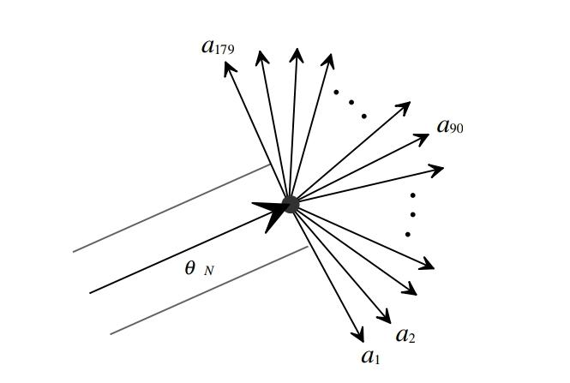

**Figure 8.1.c: Schematic of blood centerline tracking (where, $O_{i, }O_{i, },and O_{i }$**

**represents the centerline points, vessel local direction and its variation respectively.)**



*ON*

*tN*

*tN*+1

*ON*-1

θ *N*

*θ N* + 1

*θ N* – 1

*ON*+1

**Figure8.1.b: Radon transform-based feature extraction algorithm**

Before using Radon transform, weights are defined for each pixel on the basis of distance from the centerline point ON. Since the closest pixels to ON have more valuable information, the corresponding weights are higher (weights close to 1). Then radon transform is applied.

In each step, our goal is to make a prediction of the directional variation tN+1 for a new input vector $x_{N+1}$. The predictive distribution of target values is given by

$$p\left(t_{N+1}\right)=N(t_{N+1}|0,C_{N+1})$$

Since p(tN+1|tN) has a Gaussian distribution, the most probable value for tN+1 is a Gaussian distribution’s mean m(xN+1).

The new vessel direction ($θ_{N+1}$) is calculated by

$$θ_{N+1}=θ_{N}+t_{N+1}$$

where θN is the vessel’s previous direction.

In order to find a new centerline point, we move forward a step in the new vessel direction ($θ_{N+1}$).

The step length has an inverse relationship with tN+1, the step length is given by

$$d=\frac{1}{π}(\frac{π}{2}-t_{N+1})$$

By continuing on the centerline in the synthetic images and computing Radon transform, two sets of training data are given rise for tracking both the directional variation and diameter of the lumen.

**8.1.1 Estimation of kernel hyperparameter:**

When we are calculating the new vessel direction $θ_{N+1}$ we need to calculate the covariance matrix, the elements of the covariance matrix is given by using radial basis function as shown below

$$k\left(x_{n},x_{m}\right)=exp⁡({-α\left|\left|x_{n}-x_{m}\right|\right|}^{2})$$

where α is a hyperparameter controlling the degree of the correlation between the data points.

Then the next things are known from the training data by increasing the likelihood function with regard to $∝$. We update values of $α$ by gradient descent approach by moving along the gradient direction until convergence.

Using the definition of a standard multivariate Gaussian Distribution, the log likelihood function with 0 mean and $C_{N}$ variance is given as

$$P\left(t_{N} | α\right)= N(t_{N}|α ;0,C_{N})$$

The multivariant Gaussian Progression is given as

$$N\left(x:μ, ∑\right)= \frac{1}{2π}{|∑|}^{\frac{-1}{2}} exp\{\frac{-1}{2}(x-μ)∑^{-1}{(x-μ)}^{T}\}$$

The likelihood function can be written as

$$p\left(t | ∝\right)= \frac{1}{2π} {C_{N}}^{\frac{-1}{2}} exp⁡(\frac{-1}{2}\left(t\right){C_{N}}^{-1}t^{T})$$

Then, the log likihood finction is

$$p\left(t | α\right)= -\frac{1}{2}\ln\left|C_{N}\right|- \frac{1}{2}t^{T}C_{N}^{-1}t- \frac{N}{2}ln(2π)$$

The gradient of the log likelihood function with respect to $α$ parameter is

$$\frac{∂}{∂∝}\ln{p\left(t | ∝\right)= -\frac{1}{2}tr\left(C_{N}^{-1}\frac{∂C_{N}}{∂∝}\right)+\frac{1}{2}t^{T}C_{N}^{-1}\frac{∂C_{N}}{∂∝}}C_{N}^{-1}t$$

Furthermore, with respect to the predefined kernel , ∂α elements are evaluated using

$$\frac{∂C(x_{n},x_{m})}{∂∝}=-{\left|\left|x_{n}-x_{m}\right|\right|}^{2}k(x_{n},x_{m})$$

**8.2 Bifurcation Detection:**

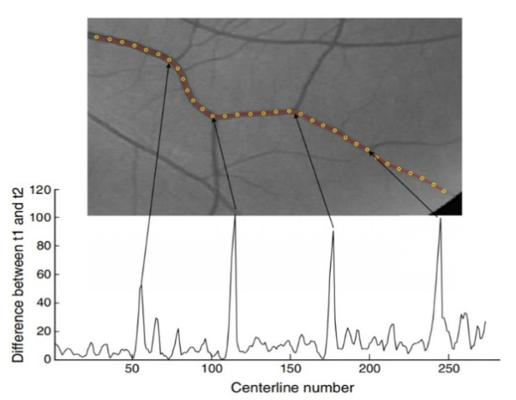

**Figure8.2.a: Approaching the bifurcations, the difference between t 1 and t 2 increases**

Thus far, tracking of only simple vessels with no bifurcations was described. To know completely about vascular tree, we need to detect the bifurcations to initiate further tracking process.

Till now we assumed zero mean GP, which will track the path with smaller directional change, a branch with larger deviation can be diminished. To overcome this we use multiple GP’s to enable tracking through both branches.

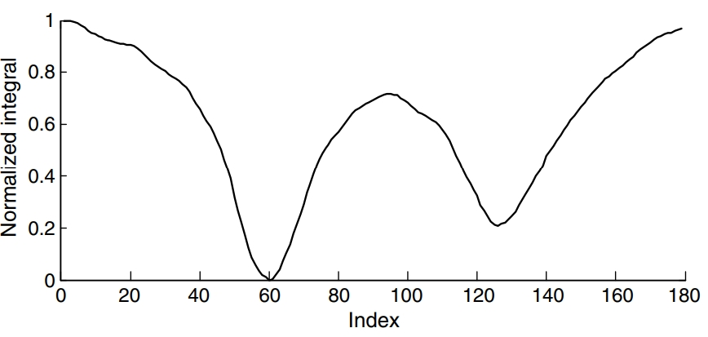

**Figure 8.2.b: A real extracted feature vector**

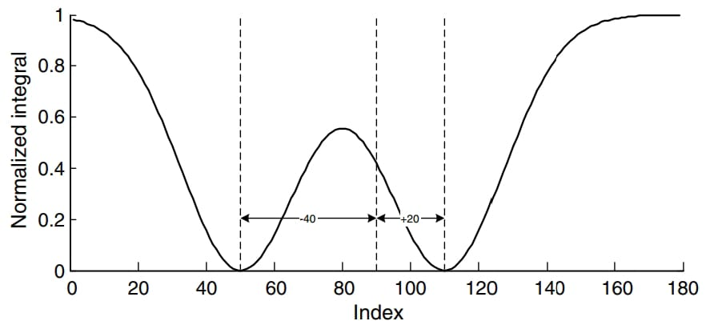

**Figure 8.2.c: A synthetic feature vector with two target values (-40, 20)**

If we overcome bifurcation two local minimums are indicated for the existing branches. So to track the smaller and larger deviation angles two independent GPs are implemented. Now we have two target vectors $t_{N,1}$ and $t_{N,2}$ indicating left and right branches respectively.

To train the GP’s, we need to add the bifurcation data to the previous data, in ordaer to detect it as a bifurcation or simple vessel points. If those training data values take different values it represents it as bifurcation else a simple vessel point.

At first kernel hypermeter is estimated than at each step two Gaussian distributions i.e. $p\left(t_{N+1,1}|t_{N,1}\right)$ and $p\left(t_{N+1,2}|t_{N,2}\right)$ are calculated as shown to estimate the new target values.

$$t_{N+1,1}=m_{1}\left(x_{N+1}\right)=k^{T}C_{N}^{-1}t_{N,1}$$

$$t_{N+1,2}=m_{2}\left(x_{N+1}\right)=k^{T}C_{N}^{-1}t_{N,2}$$

The difference between $t_{N+1,1}$ and $t_{N+1,2}$ directions is considered to be an indicator of a branching point.

If this difference suit more than 30 deg, we consider the contemporary position as a bifurcation point. When the difference between the estimated directional variations becomes less than the specified threshold, the smaller value is chosen for moving along the vessel centerline.

**8.3 Diameter estimation:**

Diameter values are also tracked with help of an an independent GP. We assume that the diameter varies smoothly bound to its initial value following a nonzero mean Gaussian distribution

$$p\left(r_{N}\right)=N(r_{N}|r_{0},J_{N})$$

where $r_{0}$ represent the vessel’s initial diameter.

Mean is calculated as

$$m\left(z_{N+1}\right)=α+k^{T}J_{N}^{-1}\left(r-a\right)$$

α and $z_{N+1}$ implies the mean of the GP and the feature vector in the N+1’th step, respectively.

$J_{N}$ and k are the kernelized covariance and similarity vector.

In each step after estimating vessel direction, we let $α=θ_{N+1}$, and vary ρ to create the diameter sensitive features.

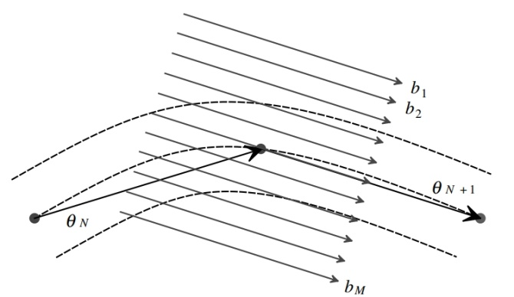

**Figure 8.3.a: Compute radon tf, setting $α= θ_{N+1}$**

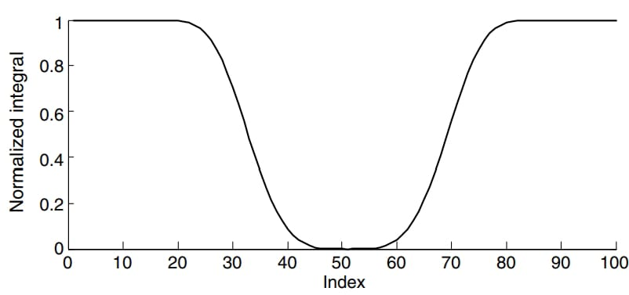

**Figure 8.3.b: Training data generated for diameter estimation**

**FLOWCHART:**

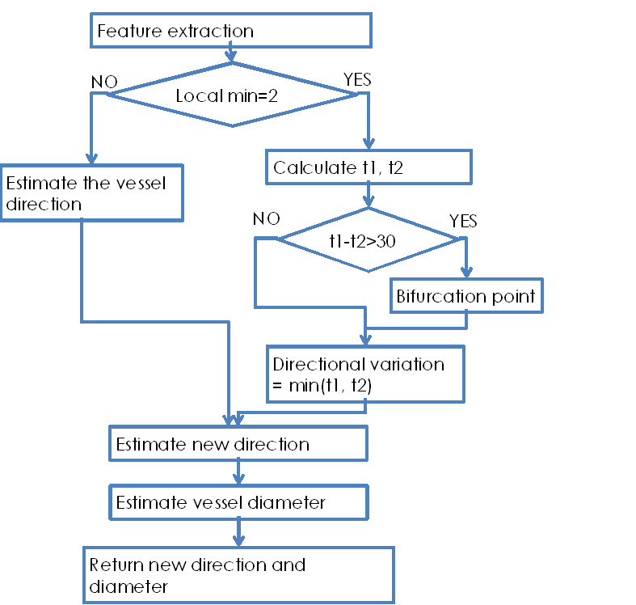

**Figure 8.3.c: flowchart**

1. **SOFTWARE DESCRIPTION**

MATLAB is considered as a high-performance language which is used for technical computing. It involves computation, visualization, and programming in a user-friendly environment.

Typically, MATLAB finds its use in the following areas

* Math and computation
* Algorithm development
* Modeling, simulation, and prototyping
* Data analysis, exploration, and visualization
* Scientific and engineering graphics
* Application development, including Graphical User Interface building.

MATLAB is that the choice for high-productivity research, development, and analysis. It is being used in institutions and researches all over.

The MATLAB system comprises of five main parts:

**The MATLAB language.**

It includes control flow statements, inputs, outputs, data structures and object-oriented features. It allows both "programming in the small" to rapidly formulate quick throw-away programs, and "programming in the large" to formulate complete large and complex application programs.

**The MATLAB working environment.**

This is the set of tools and facilities that MATLAB user or programmer works with. MATLAB environment also incorporates facilities for managing the variables in workspace and importing & exporting data. It includes functions for developing, managing, debugging, and profiling M-files, MATLAB's applications.

**Handle Graphics.**

It is the MATLAB graphics system. It includes high level commands for 2D and 3D image processing, presentation graphics, data visualization, and animation. It also includes low level commands which allows user to customize appearance of graphics and build complete GUI.

**MATLAB mathematical function library.**

MATLAB provides various algorithms used for computation which range from basic functions like sine, cosine, sum, and complex arithmetic, to complex functions like Bessel functions, matrix inverse, matrix eigen values and fast Fourier transforms.

**The MATLAB Application Program Interface (API).**

This is a library that allows us to write C and Fortran programs which interact with MATLAB. It provides facilities for calling methods from MATLAB, for reading and writing MAT-files and calling MATLAB as a computational engine.



**Figure 9.a: MAT**LAB

**Matlab functions used in our project:**

|  |  |
| --- | --- |
| FUNCTION | DESCRIPTION |
| unit8 | It converts the elements of array 8 into unsigned integer. Output ranges from 0 to 255. |
| Double | It converts the symbolic values to double precision. |
| Disp | This function displays the text or value which is stored in a variable without actually printing the name of that variable. |
| ginput | With the help of this function we can select the points from figure using the mouse for the cursor positioning. |
| Plot | It plots column X versus column Y. |
| atand | It returns the inverse tangent (tan-1) of the elements for the given inputs. |
| Sqrt | It calculates the square root, signed square root, or reciprocal square root of the given input |
| Size | It will return size of the given input (array or image). |
| repmat | This command gives output in the form of an array repetition of the original array. |
| trace | This command gives the sum of diagonal elements of the matrix. |
| Exp | This function returns the exponential of the given input. |
| permute | This command rearranges the dimension of a multidimensional array. |
| Sum | This command returns the sum of elements. |
| Abs | This command is used to get absolute value for every element in the input. |
| meshgrid | This command is used to evaluate the functions of two variable and three variable dimensional mesh or surface plots. |
| min | It returns the minimum value from the given values. |
| max | It computes the maximum value of an array or the maximum over the dimension specified in the vector. |
| imadjust | It maps the intensity values of gray scale images to the new values. |
| ndgrid | It gives rectangular grid in N D space and works as meshgrid. |
| imrotate | This command is used to rotate image by an angle in counter clock direction around its centre point. |
| interp2 | This function returns interpolated values of a function of two variables at the specific points using interpolation. |
| print | This displays the formatted text which is centred on the icon and can display the formatspec along with the content of the given variable. |

**Table 9.a: Matlab functions and its description**

**10.ADVANTAGES AND LIMITATIONS**

**Advantages:**

* Since, here apply integration in radon transform which is robust to the presence of noise
* Combining GPs with Radon features results in a significantly improved performance in dealing with noisy vessels Specific.
* Directly measures the vessel diameter.
* Computationally more efficient.

**Limitations:**

* Complexity of dealing with bifurcation.
* Computational complexity due to radon transform.
* Loss of some features due to pre-processing.
* Vessel extraction still remains an active research area.

1. **APPLICATIONS**

## Computer-aided diagnosation of ophthalmic pathologies.

## Diagnosation cardiovascular diseases.

## Detection of diabetic retinopathy and hypertension.

## DATASET

In this, project we have taken images from two types of data bases:

**DRIVE DATA SET:** This database which was introduced in 2004 possesses 40 images being captured by Canon CR5 non- mydriatic 3CCD camera at a rotation of 450 Field-Of- View (FOV) which are further classified as trained and test sets having 20 images each. Every image has a size 768 × 584 pixels and 8-bits per pixel. All the contained 40 images have normal and abnormal images which are hand-labeled by experts for analysis the performance of any proposed method. Another important feature is that the database also contains masks that separate the field-of-view (FOV) from the remaining part of the image. Also, there are two sets which are manually hand labeled images are exists. In which first set which manually hand labeled for all the 40 images is occupied as source of ground truth for analysis of segmentation results.

**STARE DATA SET:** The STARE database has 397 fundus images with size 700 × 605 pixels of each image which are captured by Top Con TRV- 50 fundus camera. It consists of annotations are related to 39 retinal distortions concerning each image. The Specific dataset of 40 images provides the ground truth for segmentation categorized in two sets during which the primary set which is being hand labeled is given as ground truth while the other set being hand labeled can be treated as a second observer.

**Figure12.a: Images from DRIVE dataset**

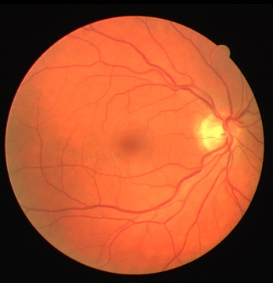   

**Figure12.b: Images from STARE dataset**

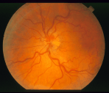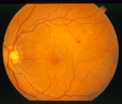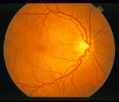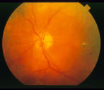

**Figure12.c: Images from CHASEDB1 dataset**

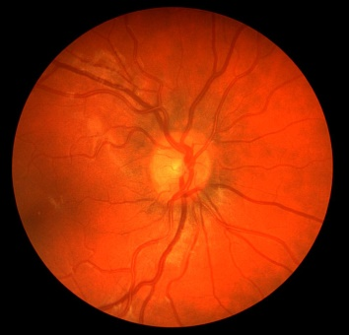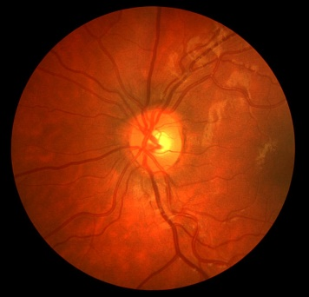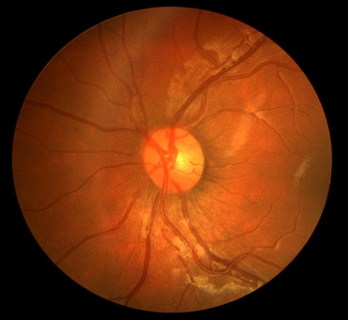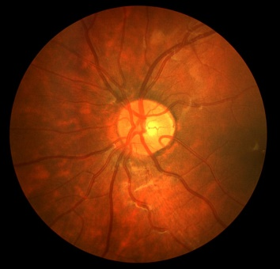

## 13. ALGORITHM

**Input:** vessel direction and initial diameter (seed point)

**Output:** Vessel direction bifurcation detection and diameter estimation

1. The corresponding feature vector related to the seed point is computed using radon transform (distance ‘ $ρ$’ = 0)
2. Estimate the kernel’s hyperparameter value
3. Generate the covariance matrix which is used to estimate the directional variation
4. Calculate target directions t1 and t 2
5. **if** ( $t_{1}$ − $t_{2}$ > 30) **then**
6. Indicate that particular point as bifurcation
7. **else**
8. It is a simple vessel
9. Continue the process by selecting the directional variation as min(t1, t2)
10. Estimate new direction
11. **end if**
12. Compute diameter-related features using Radon transform (θ = $θ_{N+1}$)
13. Generate the covariance matrix used to estimate the vessel diameter
14. Estimate the vessel diameter ($r_{N+1}$)
15. return $θ_{N+1}$ and $r_{N+1}$

## 14. RESULTS

## By this project we can able to track the vessel centerline, detect the bifurcation points and also calculate the diameter of the vessel along the vessel effectively.

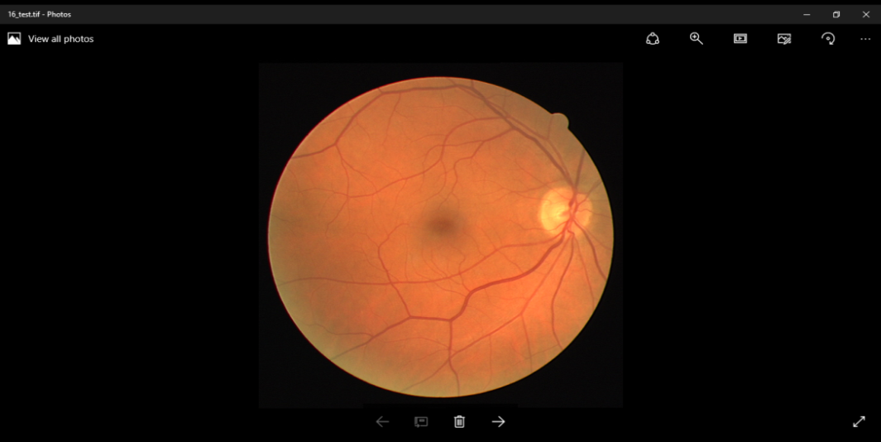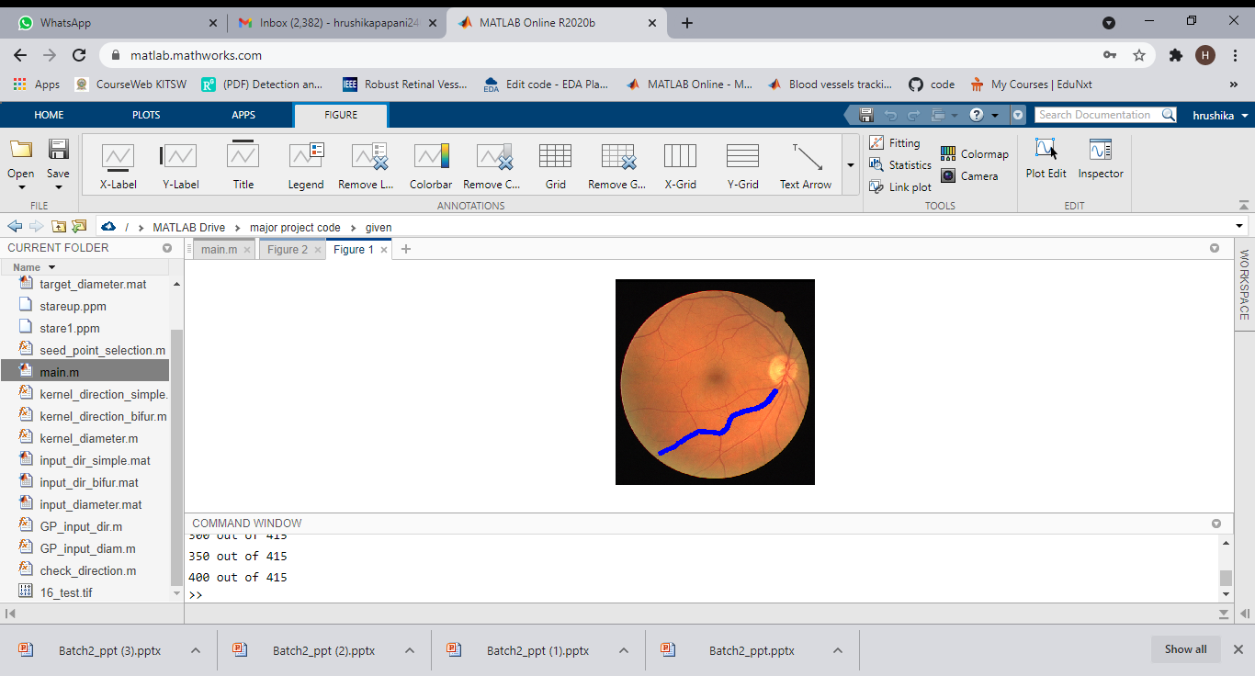

1. **(b)**

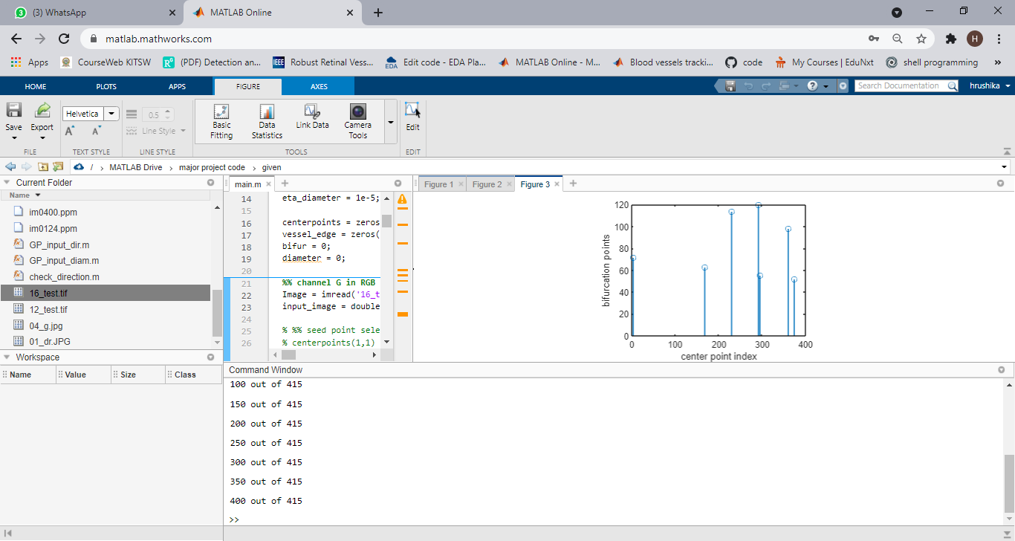 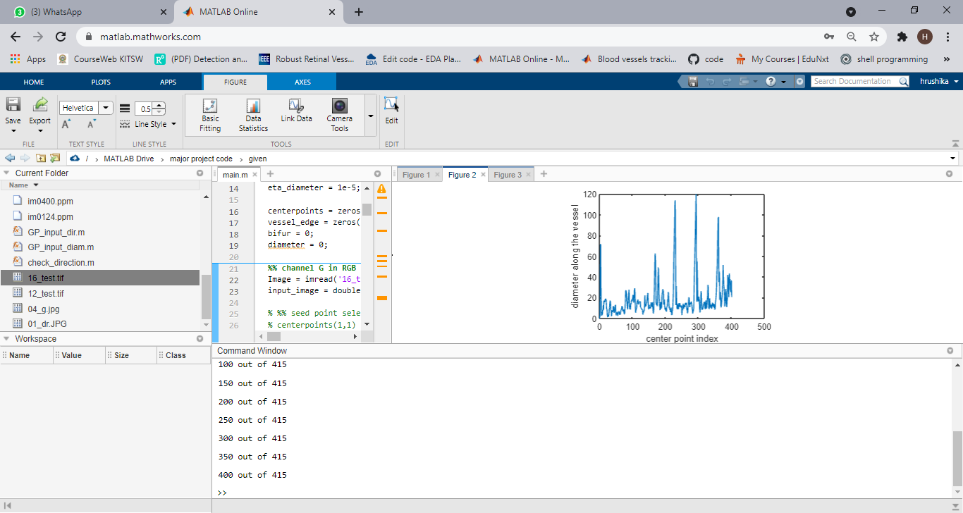

**(c) (d)**

**Figure 14.a: results for DRIVE image1 (a)DRIVE input image1 (b)traced vessel (c)diameter estimation (d)bifurcation detection**

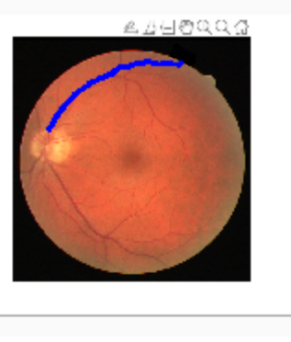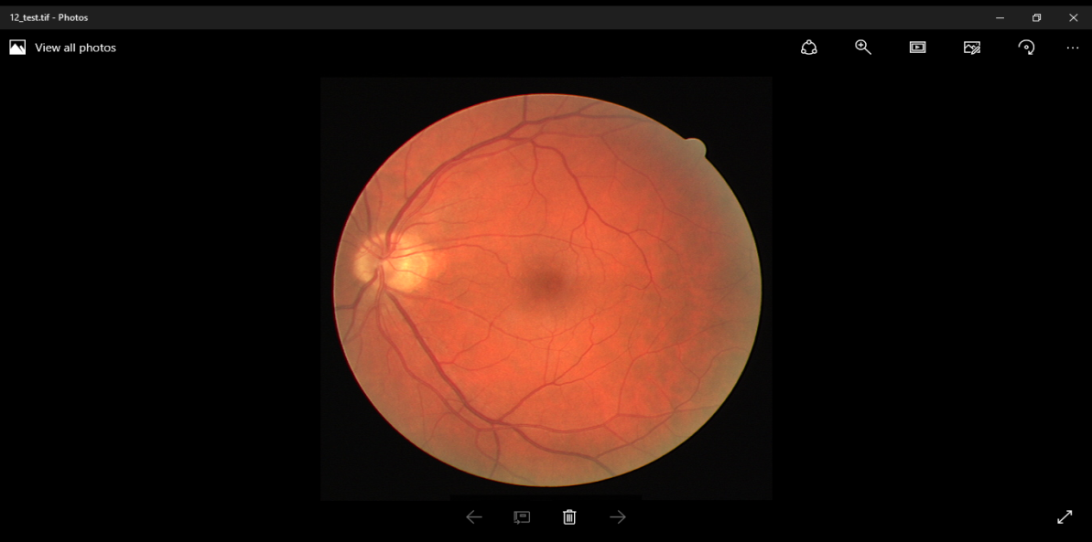

1. **(b)**

** **

**(c ) (d)**

**Figure 14.b: Results for DRIVE image2(a)DRIVE input image2 (b)traced vessel (c)diameter estimation (d)bifurcation detection**

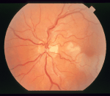 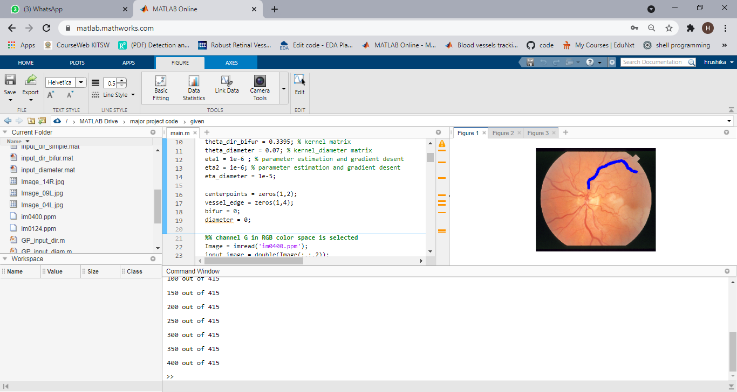

1. **(b)**

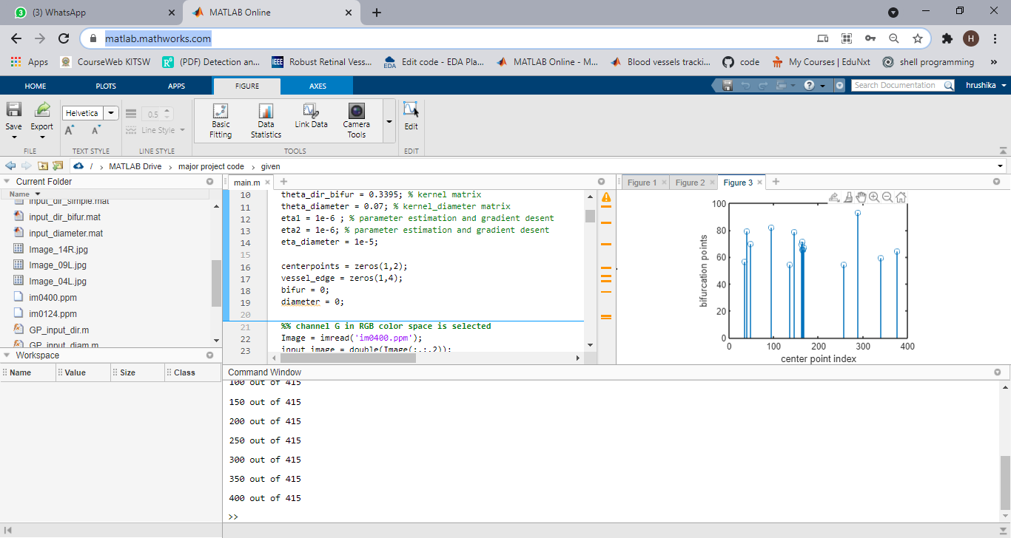 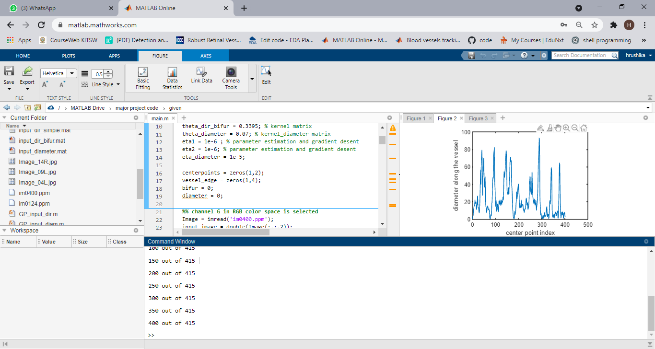

**(c) (d)**

**Figure 14.c: Results for STARE image1 (a)STARE input image3 (b)traced vessel (c)diameter estimation (d)bifurcation detection**

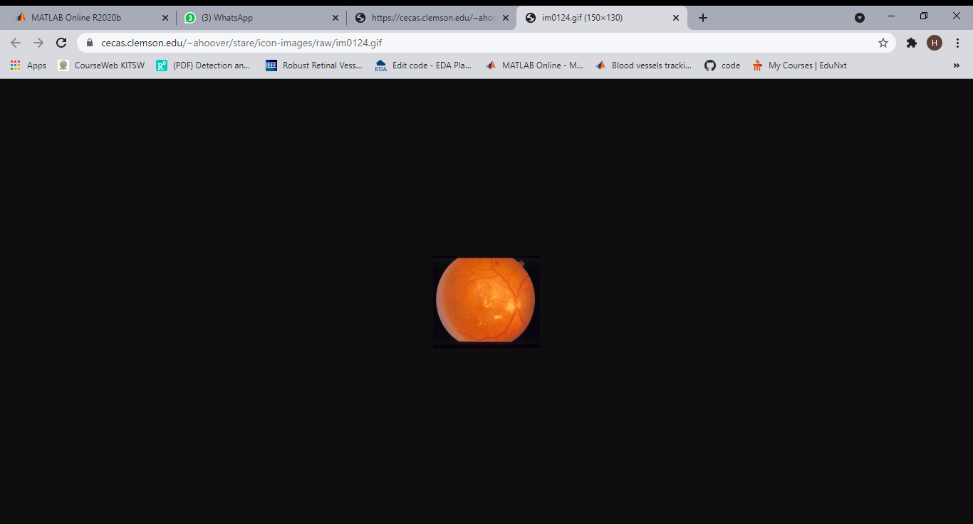 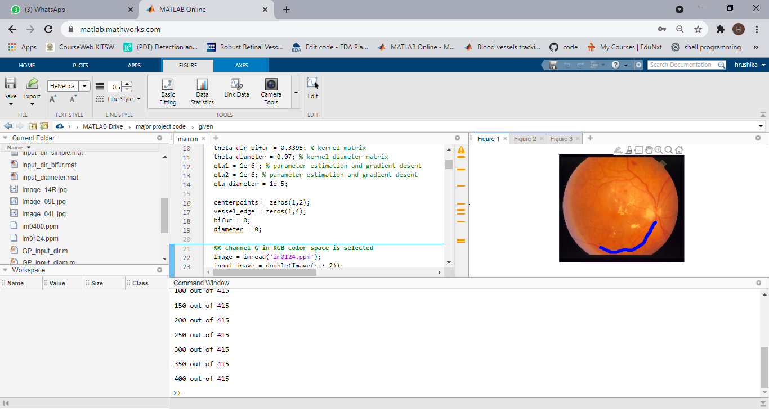

1. **(b)**

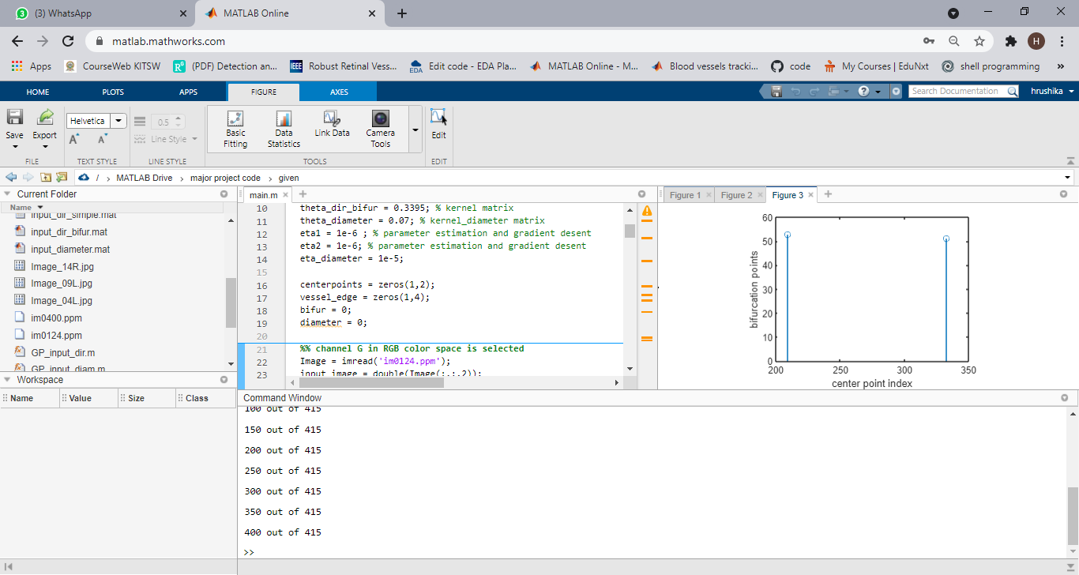 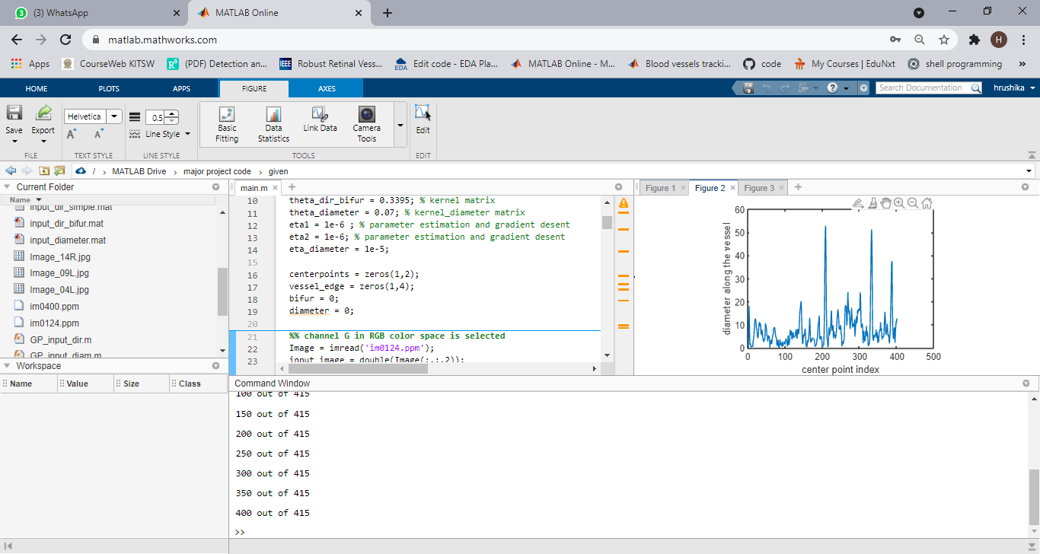

**(c ) (d)**

**Figure 14.d : Results for STARE image 2 (a)STARE input image4 (b)traced vessel (c)diameter estimation (d)bifurcation detection**

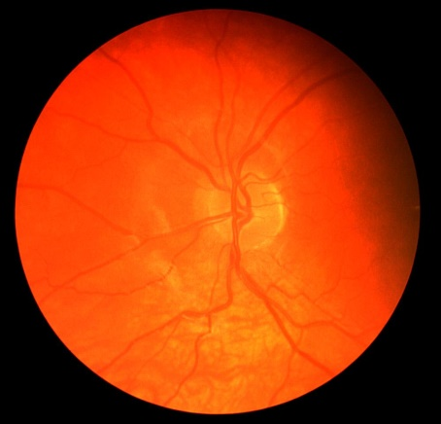 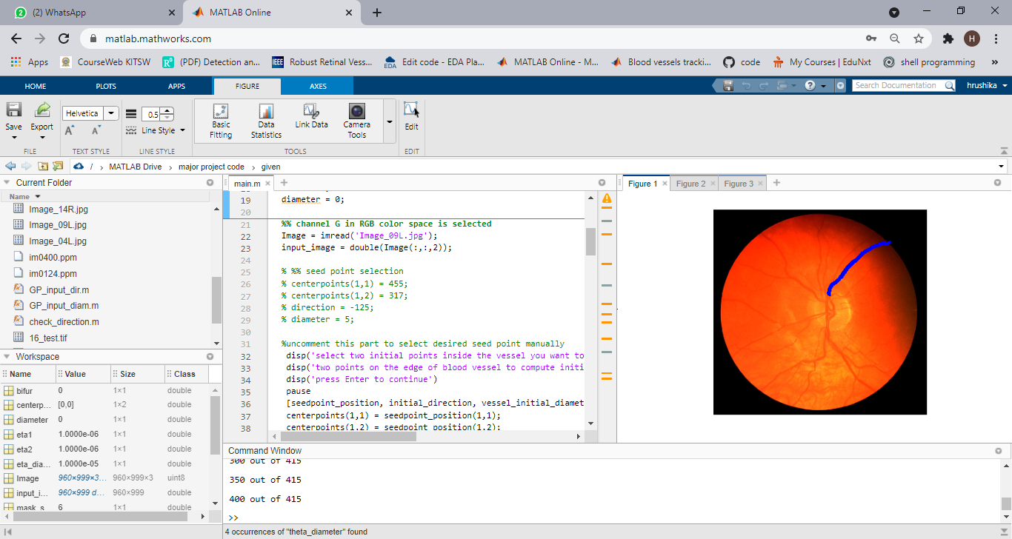

1. **(b)**

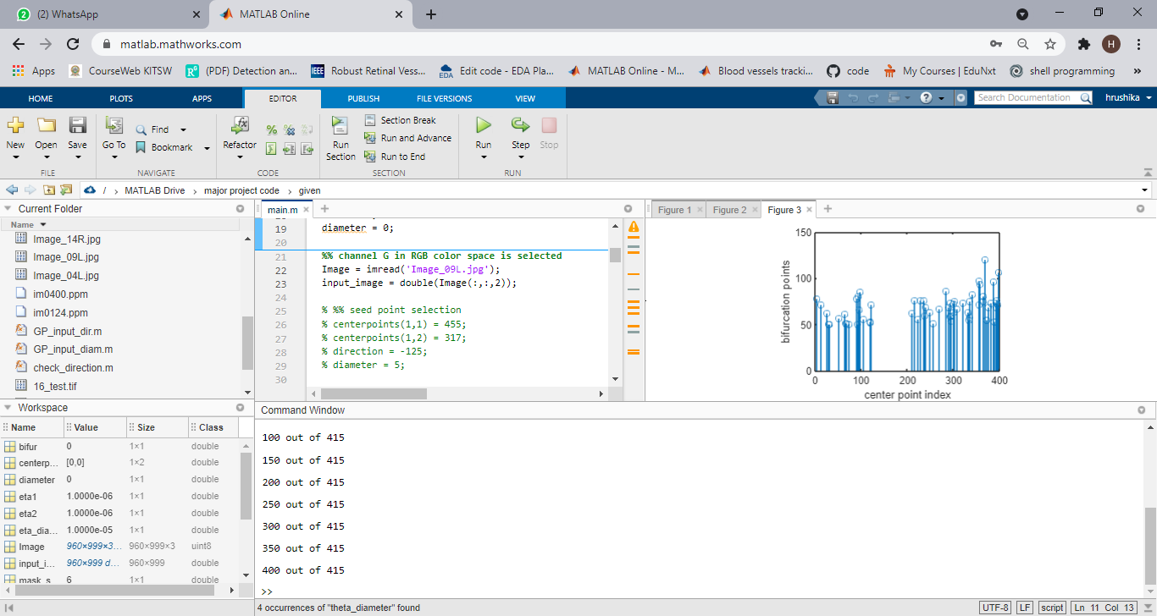 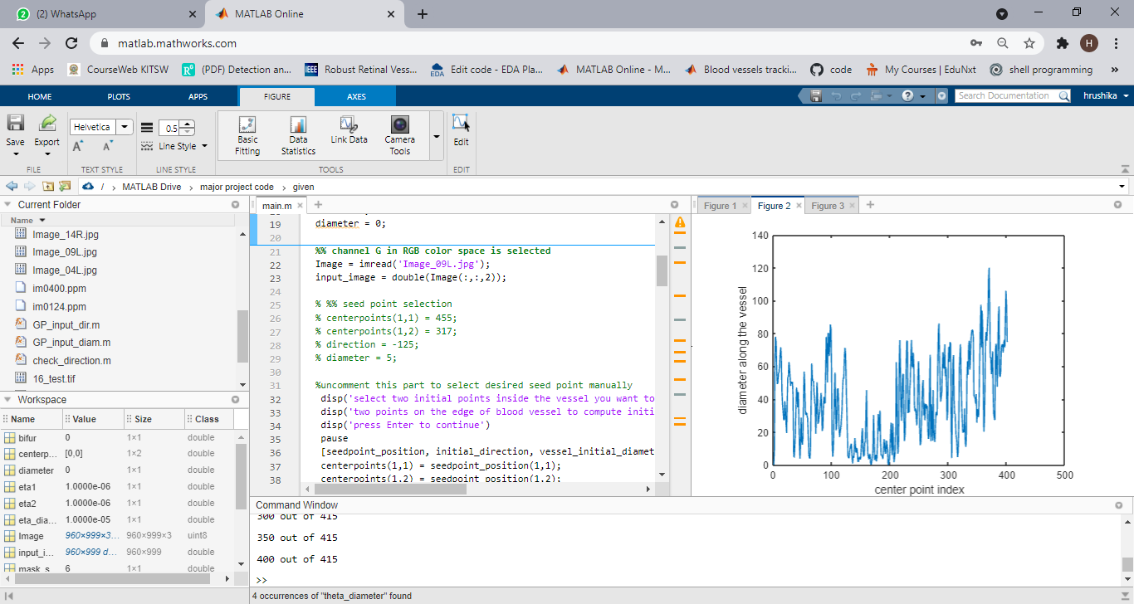

(c ) (d)

**Figure 14.e: Results for CHASEDB1 image 1 (a)CHASEDB1 input image5 (b)traced vessel (c)diameter estimation (d)bifurcation detection**

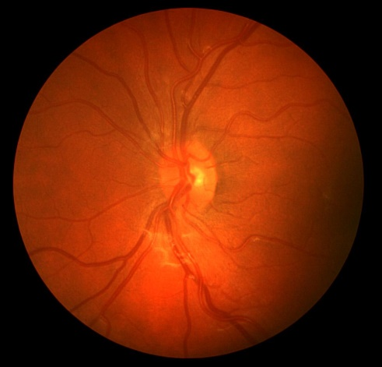 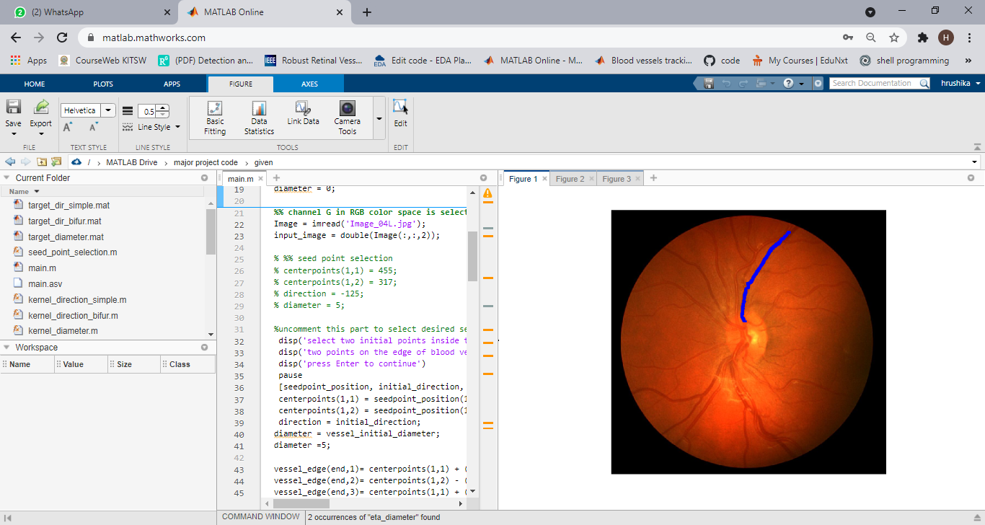

1. **(b)**

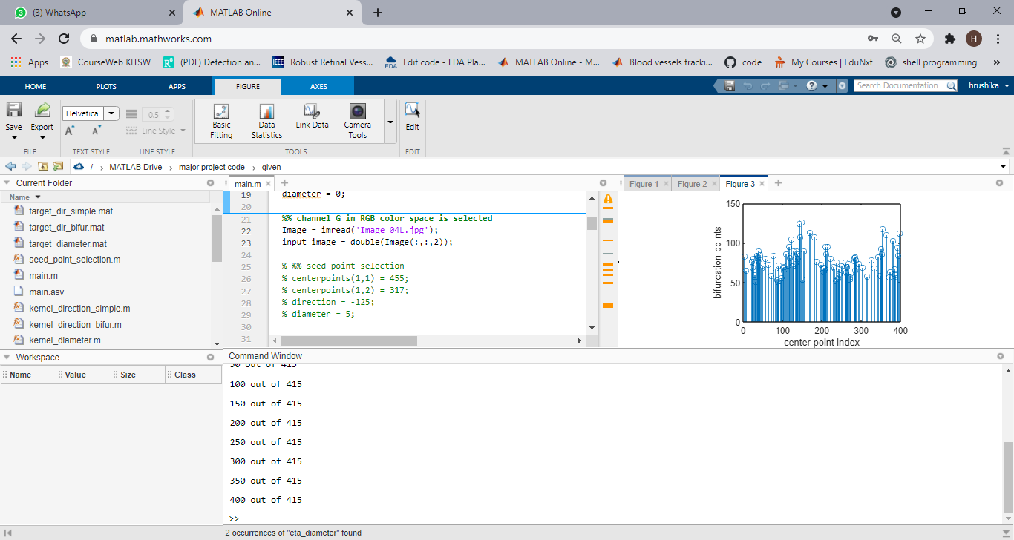 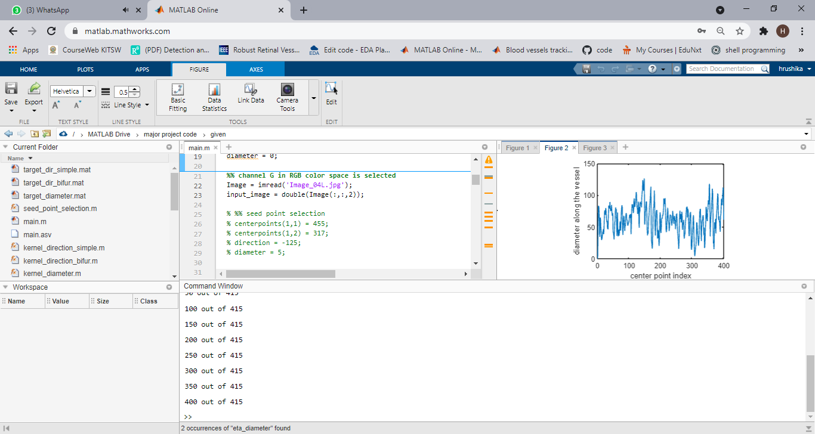

**(c ) (d)**

**Figure 14.f: Results for CHASEDB1 image2 (a)CHASEDB1 input image6 (b)traced vessel (c)diameter estimation (d)bifurcation detection.**

**PERFORMANCE CRITERIA**

The performance is evaluated based on classification of pixels into positive (vessel) and negative (background) groups. At the final stage of the tracking step, the centerline and diameter tracking results are used to construct a binary image, segmenting the vascular network from the background. Pixels in the neighborhood of each centerline point with radius d are considered as vessel, where d indicates the corresponding diameter. By comparing the segmentation result to the reference labelled data, we are able to quantify segmentation quality.

We compare every resulting binary image with the corresponding ground truth by computing the subsequent four performance measurements: the pixels that belong to a vessel within the ground truth image, the pixels that are classified as vessels are counted as true positives (TP), else they are counted as false negatives (FN). The pixels that belong to the background and that are classified as non-vessels, are counted as true negatives (TN), otherwise they are counted as a false positives (FP).

1. True positive (TP): It gives pixels that are correctly identified.
2. False-positive (FP): It gives pixels that are incorrectly identified.
3. True negative (TN): It gives pixels that are correctly rejected.
4. False-negative (FN): It gives pixels that are incorrectly rejected.

In order to evaluate the performance of the proposed method, we compute the sensitivity (SN), specificity (SP) and Matthews correlation coefficient (MCC). These metrics are defined as follows:

**Sensitivity (SN):**

It tells us about the ability of an algorithm to detect the vessel pixels. It is measured by the ratio of the no. of truly classified vessel pixels to the total no. of vessel pixels in the image field of view.

SN = $\frac{TP}{TP+FN}$

TP+FP give the total number of background pixels.

**Specificity (SP)**:

It is the ability to detect non-vessel pixels and is measured by the ratio of the number of correctly classified background pixels to the total number of background pixels.

SP = $\frac{TN}{TN+FP}$

TP+FN give the total number of pixels.

**Matthew’s correlation coefficient (MCC):**

The MCC is often used to measure the quality of a binary classification system when the size of samples in the two classes varies substantially.

MCC = $\frac{\frac{TP}{N}-S×P}{\sqrt{P×S×(1-S)×(1-P)}}$

Where, N=TP+TN+FP+FN

Number of pixels in the image

S= $\frac{TP+FN}{N}$; P= $\frac{TP+FP}{N}$

In retinal fundus images, around 10%ofthe pixels belong to the vessels; therefore, the MCC can be used to evaluate the algorithm’s performance. The MCC is defined as

MCC returns a value between −1 and +1.

Where, +1 indicates a perfect prediction,

0 indicates a random prediction,

and −1 implies a completely wrong prediction.

The higher values of true positive fractions, true negative fractions lead to good segmentation results and similarly, higher values of false positive fractions, false negative fractions lead to worst segmentation results.

**COMPARISION WITH OTHER STATE OF ARTS:**

|  |  |  |  |  |  |  |  |  |  |
| --- | --- | --- | --- | --- | --- | --- | --- | --- | --- |
|  | **DRIVE** | **DRIVE** | **DRIVE** | **STARE** | **STARE** | **STARE** | **CHASEDB1** | **CHASEDB1** | **CHASEDB1** |
| **Methodology** | **SN** | **SP** | **MCC** | **SN** | **SP** | **MCC** | **SN** | **SC** | **MCC** |
| Azzopardi et al | 0.7655 | 0.9704 | 0.7475 | 0.7716 | 0.9701 | 0.7335 | 0.7585 | 0.9587 | 0.6802 |
| Zhang et al | 0.7743 | 0.9725 | ---------- | 0.7791 | 0.9758 | ---------- | 0.7626 | 0.9661 | ---------------- |
| Strisciuglio et al | 0.7777 | 0.9725 | 0.7525 | 0.8046 | 0.9710 | 0.7536 | ---------------- | ---------------- | ----------------- |
| Ornaldo et al | 0.7897 | 0.9684 | 0.7556 | 0.7680 | 0.9738 | 0.7417 | 0.7277 | 0.9712 | 0.7046 |
| Proposed method | 0.7428 | 0.9732 | 0.7428 | 0.7419 | 0.9706 | 0.7248 | 0.7535 | 0.9767 | 0.7062 |

**Table 14.a : Comparison of proposed method with existing methods**

**15.CONCLUSION**

The segmentation of the blood vessels in the retina has been a heavily researched area in recent years. The accurate extraction of the retinal vascular tree forms the backbone of many automated computer aided systems for screening and diagnosis of cardiovascular and ophthalmologic diseases. Even though many promising techniques and algorithms have been developed, there is still room for improvement in blood vessel segmentation methodologies. Here a new approach is presented where the blood vessel centerline tracking method is done by GP regression and radon transform. Detection of bifurcations and tracking the diameters and done by applying multiple GP’s. At first features are extracted by radon transformation then to track the vessel centerline we assume a single vessel fragment with no bifurcations and the curvature varies smoothly and has Gaussian distribution whose kernel parameters are optimized by maximizing the likelihood of the data. The proposed method is robust to noise and thus able to track thin structures and central arterial reflex, where the signal quality drops significantly, this can be proved by calculating the performance of the algorithm on the retinal images in DRIVE, STARE, CHASEDB1, and HRF databases, with ground truth pixel labels. This is because of integration of the local intensities used to compute the Radon transformations. Furthermore, the smoothness in the centerlines is enforced by spatial correlations of the predictions made by GP. The result is an increased specificity level when compared to other methods. The proposed method directly measures the vessel diameters and detects the bifurcation points. The proposed method relies on inverting covariance matrices and computing line integrals for Radon transformations, which can be computationally expensive.

Future scope: One possible interesting research direction is the development of a mechanism to make the algorithm computationally more efficient. This can be achieved using methods such as sparse GPs49,50 or Fourier transforms to compute the Radon features.

**REFERENCES**

[1].Radhika Y, Santhosh Kumar NC, “optimized maximum principal curvature-based segmentation of blood vessels from retinal images”, Biomedical Research 2019, Vol 30, Issue 2, pp. 308-318.

[2].Verma K, Deep P, Ramakrishnan AG. “Detection and classification of diabetic retinopathy using retinal images flight”. Annual IEEE India Conference (INDICON) 2011, pp 1-6.

[3].Ikibas C. ,Kose C, “A personal identification system using retinal vasculature in retinal fundus images”. Exp Sys Appl 2011, Vol. 38, pp. 13670-13681.

[4].G. Azzopardi et al., “Trainable COSFIRE filters for vessel delineation with application to retinal images,” Med. Image Anal. 19(1), 46–57 (2015).

[5].N. Strisciuglio et al., “Supervised vessel delineation in retinal fundus images with the automatic selection of B-COSFIRE filters,” Mach. Vision Appl. 27(8), 1137–1149 (2016).

[6].J. I. Orlando, E. Prokofyeva, and M. B. Blaschko, “A discriminatively trained fully connected conditional random field model for blood vessel segmentation in fundus images,” IEEE Trans. Biomed. Eng. 64(1), 16– 27 (2017).

[7]. J. Zhang et al., “Robust retinal vessel segmentation via locally adaptive derivative frames in orientation scores,” IEEE Trans. Med. Imaging 35(12), 2631–2644 (2016)